**Project Design Phase-**

**IITechnologyStack(Architecture&Stack)**

|  |  |
| --- | --- |
| Date | 30 October 2022 |
| TeamID | PNT2022TMID34251 |
| ProjectName | EmergingMethodsForEarlyDetectionofForestFi res |
| MaximumMarks | 4Marks |

**Technical**

**Architectur**

**e**

Messages

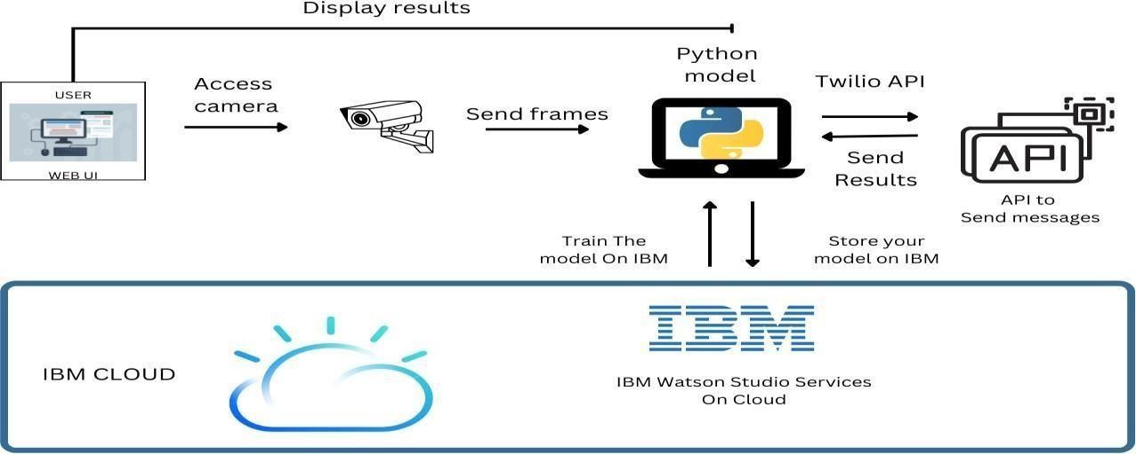

**Table-1:**

**Components&Technologies:**

|  |  |  |  |
| --- | --- | --- | --- |
| **S.No** | **Component** | **Description** | **Technology** |
| 1. | UserInterface | Theuserusestheconsoletoaccesstheinterface | Python/HTML ,CSS , Javascript andreact.Js |
| 2. | Input | VideoFeed | WebCamera/Video onasite |
| 3. | Conversion | VideoinputtedisconvertedintoFrames | FrameConverter |
| 4. | FeedingtheModel | TheFramesaresenttotheDeeplearningmodel | OurModel |
| 5. | Dataset | UsingTestsetandTrain set, trainthemodel | DatasetfromCloudStorage,Database |
| 6. | CloudDatabase | Themodelistrainedinthe  cloudmoreprecisewithdetectionsmoreimagescanbeaddedl ateron. | IBMCloudant,PythonFlask. |
| 7. | Infrastructure(Server/Cloud),A PI | Application Deployment on Local System /  CloudLocal,CloudServerConfiguration,TwilioAPItosen dmessages | Java/python, React.Js,  JavaScript,HTML,CSS,IBMCloud,O  PEN CV,  AnacondaNavigator,Local. |

**Table-2:**

**ApplicationCharacteristics:**

|  |  |  |  |
| --- | --- | --- | --- |
| **S.No** | **Characteristics** | **Description** | **Technology** |
| 1. | Open-SourceFrameworks | PythonFlaskframeworkis used | TechnologyofOpensourceframework |
| 2. | SecurityImplementations | Mandatory Access Control (MAC) andPreventativeSecurityControlisuse d | e.g.SHA-  256,Encryptions,IAMControls,O WASPetc. |
| 3. | ScalableArchitecture | Highscalabilitywith3-tierarchitecture | Web server – HTML ,CSS  ,JavaScriptApplicationserver–  Python,AnacondaDatabaseserver– IBMDB2 |
| 4. | Availability | Useofloadbalancingtodistribute trafficacrossservers | IBMloadbalancer |
| 5. | Performance | EnhancetheperformancebyusingIBMCDN | IBMContentDeliveryNetwork |